Monkeypox Fast Facts

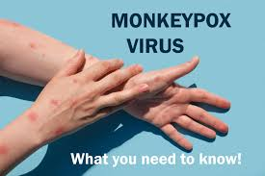
Background¹
Monkeypox is a rare disease caused by the Monkeypox virus. The virus is a member of the Orthopoxvirus genus in the family Poxviridae which is the same family of viruses that cause smallpox. Symptoms are similar to smallpox, but milder, and is rarely fatal.¹ Monkeypox cases are increasing across the United States and many parts of the world. It is contagious mainly through skin contacts, although uncommon droplet transmission has been reported.

Current Outbreak of West African Clade of Monkeypox¹
Period of Communicability³ | Current outbreak Characteristics³ | Mode of Transmission¹
- Patients are infectious once symptoms begin  - Remain infectious until lesions form scabs, scabs fall off, and a fresh layer of skin forms | Atypical presentation of classical Monkeypox  Prodromal symptoms  - Mild fever or not occurring.  - Classically: fever, malaise, headache, sore throat, cough  Rash  - Firm, pimple-like lesions, but often starting in genital and perianal areas.  - Sometimes not disseminating to other parts of body  - Easily confused with sexually transmitted infections  - STI diagnosis does not exclude Monkeypox infections, infections may be concurrent  - Classically: rash develops in mouth then extremities, face 1-2 days following prodrome. It could involve palms and soles | High and intermediate Risk Exposures  - Human-to-human transmission  - Direct contact from fluid of lesion materials  - Sustained skin-to-skin  - Sexual contact  - Contact with contaminated fomites (e.g., shared linens)  Uncommon Risk exposures  - Exposure to respiratory secretions during prolonged, face-to-face contact  *Not easily transmitted. Transmission of Monkeypox requires prolonged close interaction with a symptomatic individual.
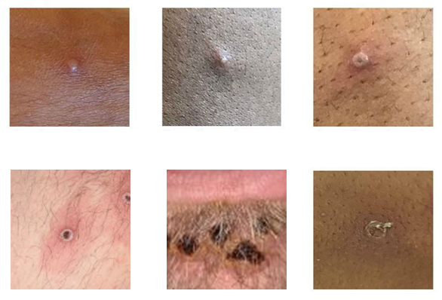

Examples of Monkeypox Rashes
Photo credit: UK Health Security Agency³

